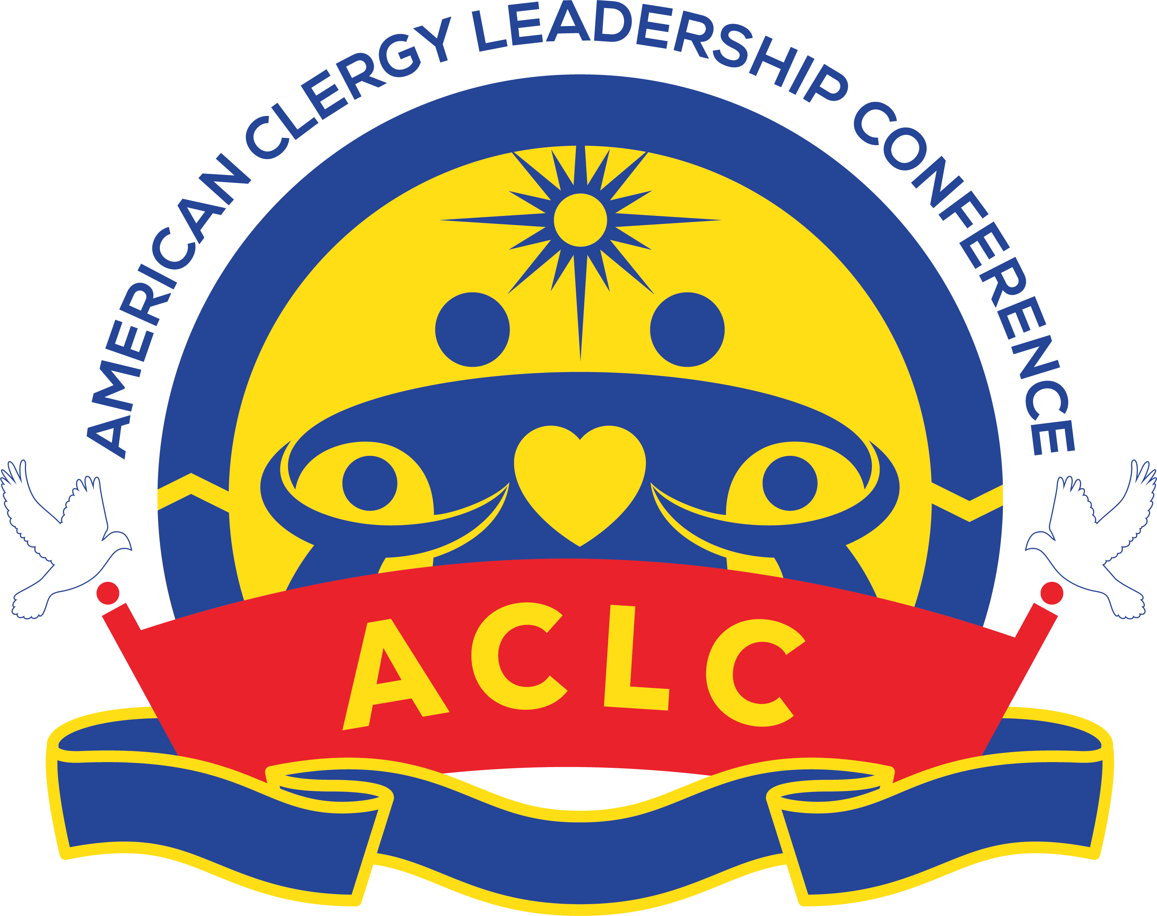
AMERICAN CLERGY LEADERSHIP CONFERENCE
Rebuild the Family, Restore the Community and Renew the Nation and the World

BECOME A PARTNER TODAY

All Partners will receive a Welcome Package - ACLC pin, Ministry Pamphlets, USB with True Family Values Education, a Mother of Peace memoir and an invitation to international events and National Convocation.

____ Executive Partner: $1,200/yr., or $100/mo. ____ Gold Partner: $720/yr., or $60/mo.
____ Bronze Partner: $360/yr., or $30/mo.
____ Covenant Partner: $120/yr., or $10/mo.

Title: _______ First Name: ____________________________ Last Name: ________________________

Mailing address: _______________________________________________________________________

City: ____________________________________ State: ___________ Zip: ______________________

Email (required): _______________________________________________________________________

Cell phone: ___________________________

Church or Organization: ______________________________ Your Position: _______________________

Payment by Cashier’s Check

Amount to be charged: $_________ monthly $_________yearly or $_________ one time only

Please enclose a blank check or provide the following:

Checking Acct. ABA Transit Routing #: ___________________________ Account #: __________________________
(Withdrawals made first week of the month)
Signature: __________________________________________________ Date: _______________________

Please Send check to :

American Clergy Leadership Conference HSA Financial Office
4 West 43rd Street, New York, NY 10036

